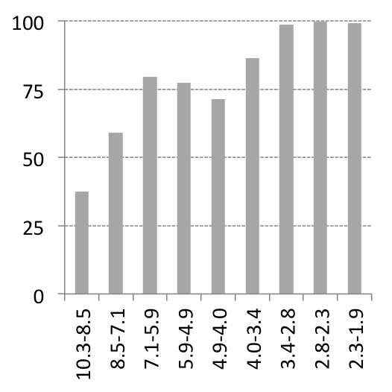

Completeness (%)

Resolution (Å)

d