Connected regions of electron-density map (below referred to as blobs) that have smaller volume than a typical volume of a reliably placed atom at some threshold level t1 can be thought of as noise and considered for elimination. Moreover, we would like to eliminate not only these blobs shown at t1, but also we want to remove their “roots” – these same blobs as they appear at a lower threshold t1-δ. Lowering threshold down to t1-δ may result in some blobs originally scheduled for elimination merge with blobs that were not considered for elimination. Such blobs are retained. Schematically this illustrated at figure 1. Figure 1(a) shows blobs numbered as 0,1,2,3 at threshold level t1 where blobs 1,2,3 are selected for elimination based on their volume. Figure 1(b) is the same as figure 1(a) but contoured at t1-δ threshold. Here we will remove blobs 2 and 3, but blob 1 will be kept since it merges with the blob 0 that was not selected for elimination. The map connectivity analysis algorithm is used for blobs identification as described by Lunina et. al. (2003).

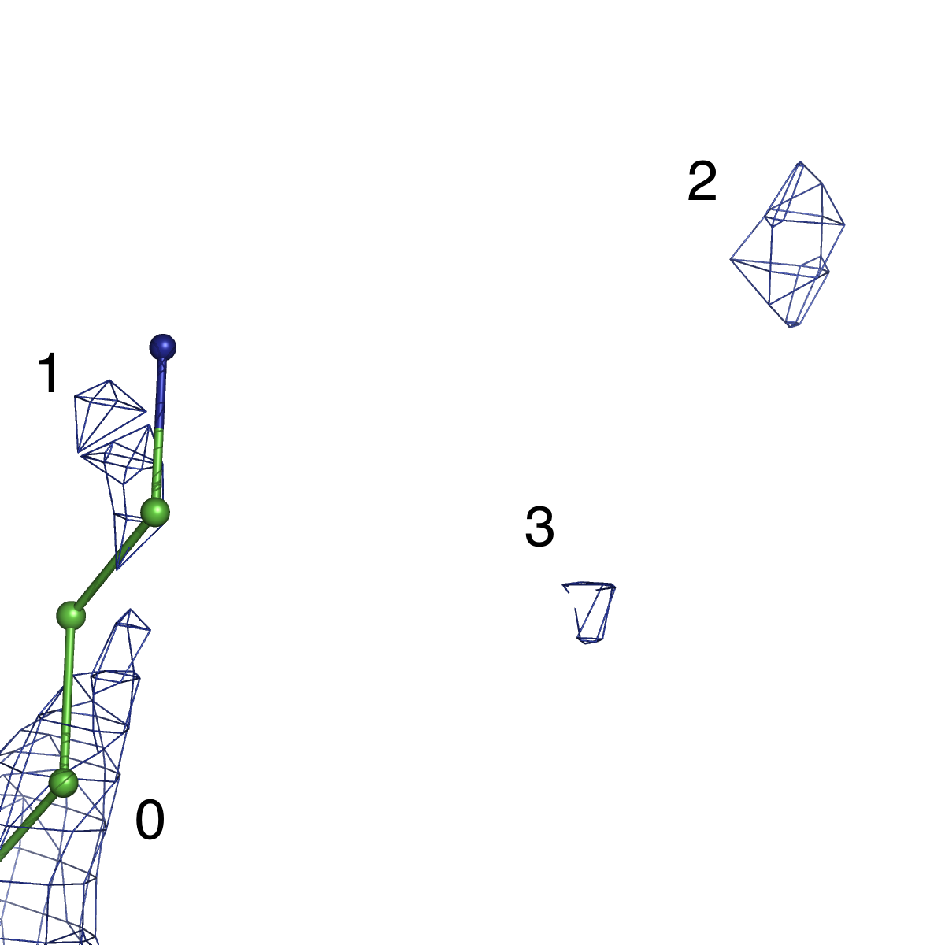 | 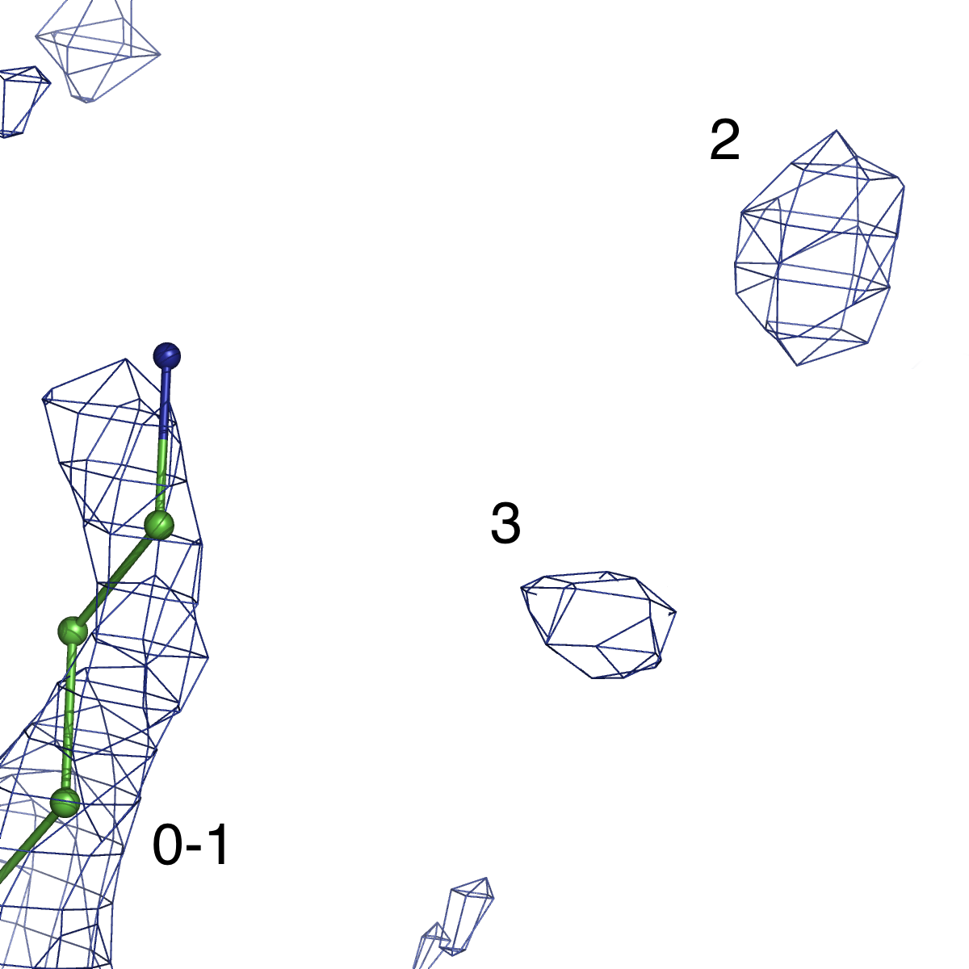

Figure. 1. Schematic illustration of noise peaks elimination. (a) map contoured at threshold level t1, blobs 1,2,3 are selected for elimination, whole blob 0 is retained. (b) Map contoured at threshold level t1-δ. We note the blob 1 merges with blob 0, and therefore it is retained, while bigger blobs 2 and 3 are removed.

